Below contains only the required screenshots that were requested as per the instructions (See main response word document titled “Liu” for all required and relevant screenshots)

**CONTROL FLOW FOR POPULATING DimMovie**

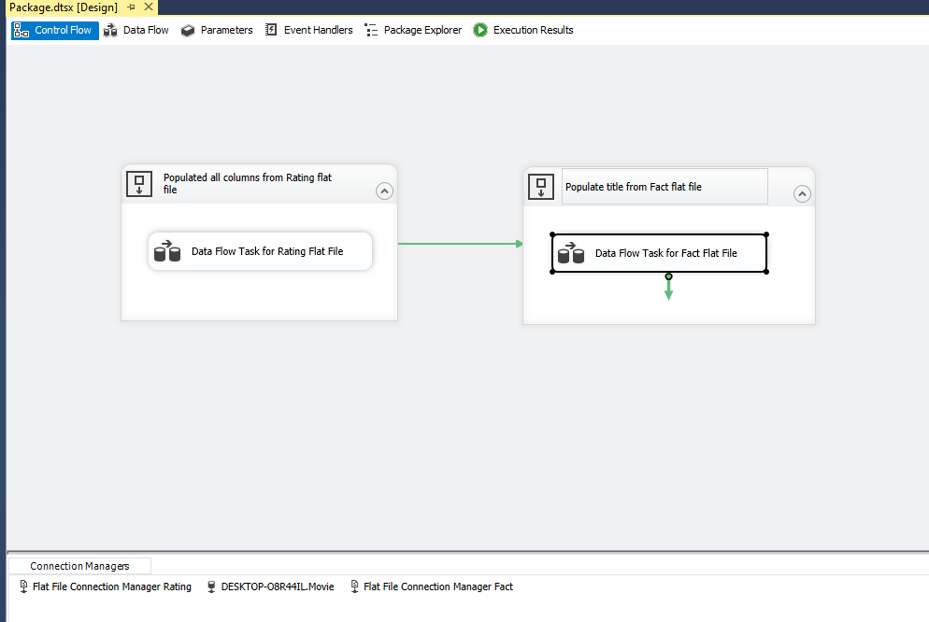

**DATA FLOW FOR POPULATING DimMovie USING Rating.txt**

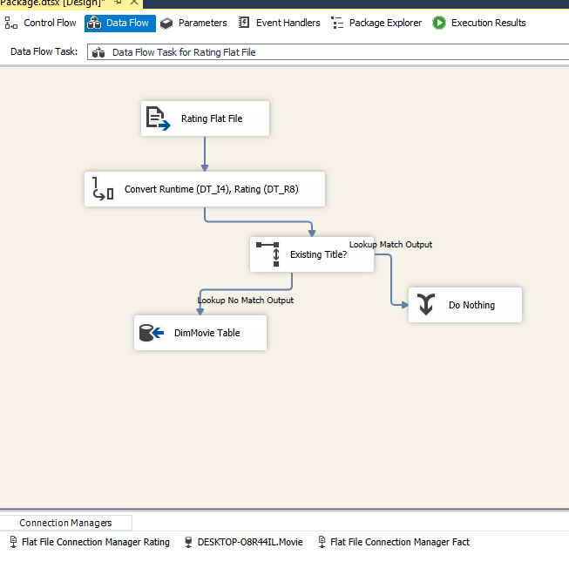

**DATA FLOW FOR POPULATING DimMovie USING Fact.txt**

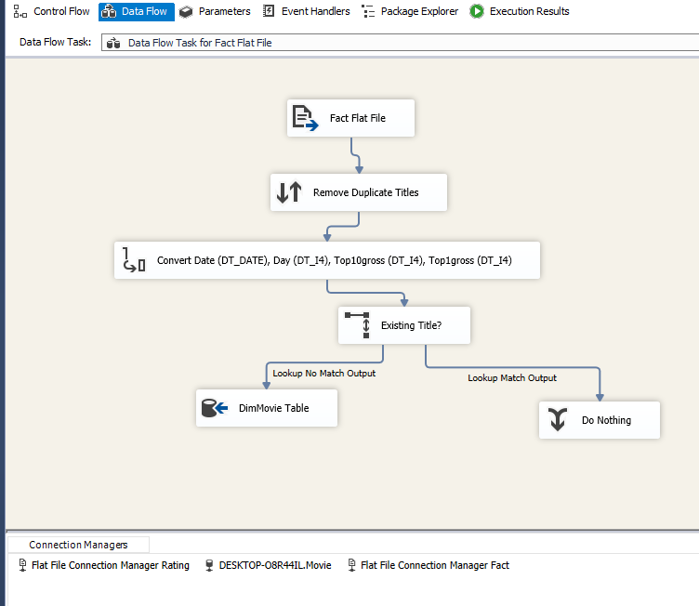

**DATA FLOW FOR POPULATING FactMovie USING Fact.txt**

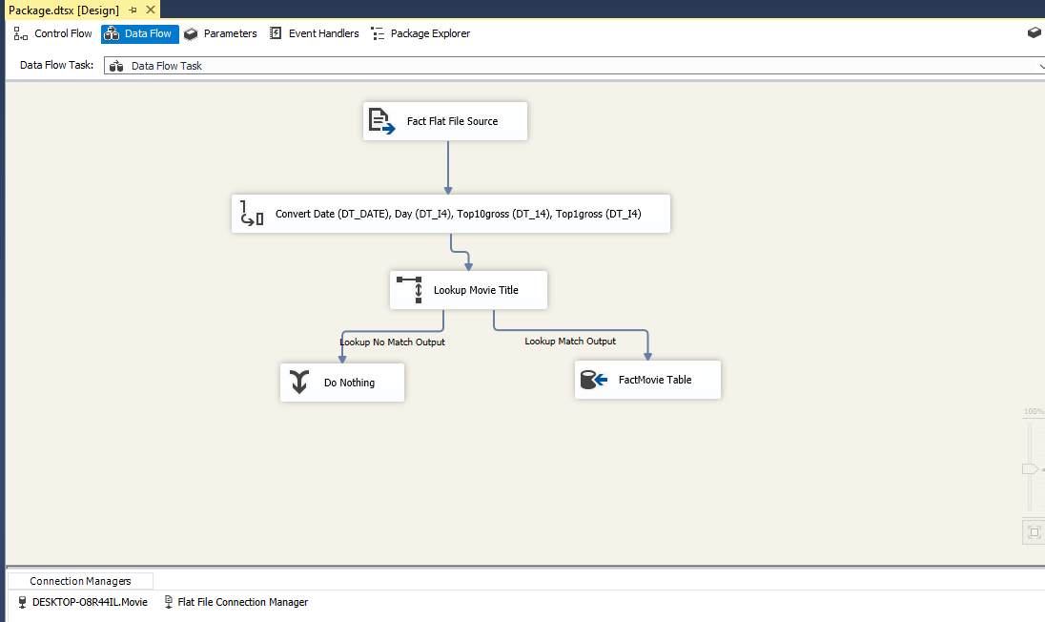

**DATABASE DIAGRAM OF Movie DATABASE**



**TIME SERIES CHART**

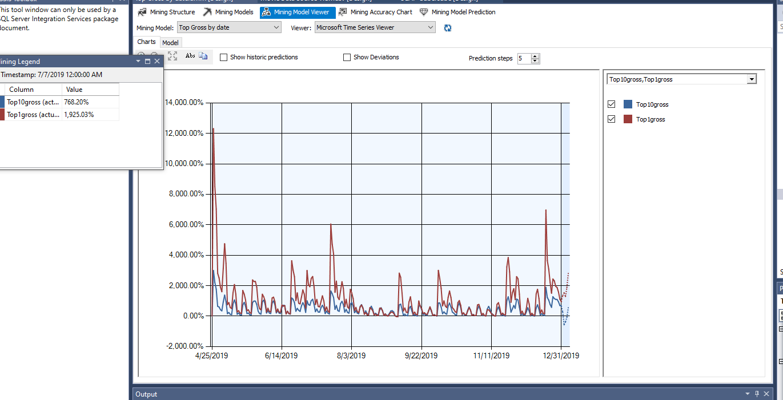

**TIME SERIES CHART (NO Top1gross)**

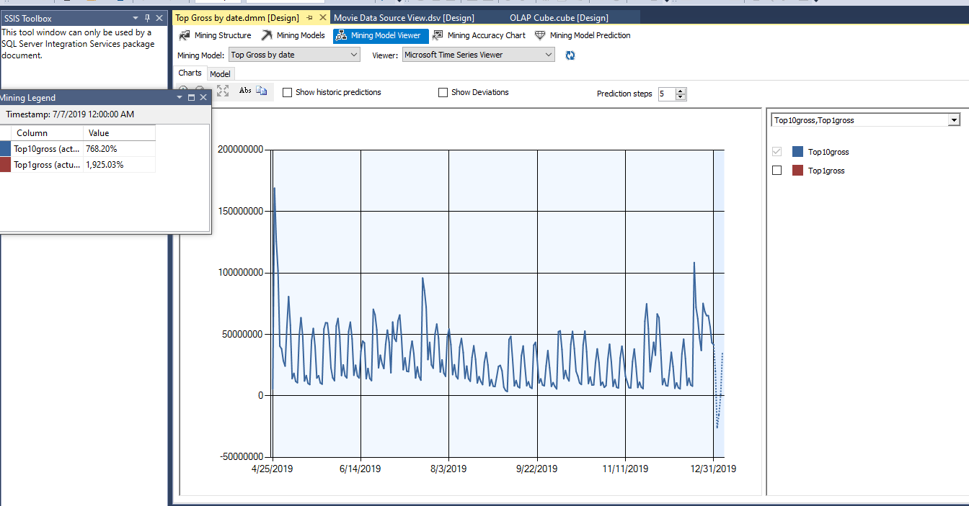

**TIME SERIES MODEL 5 DAYS PREDICTION**

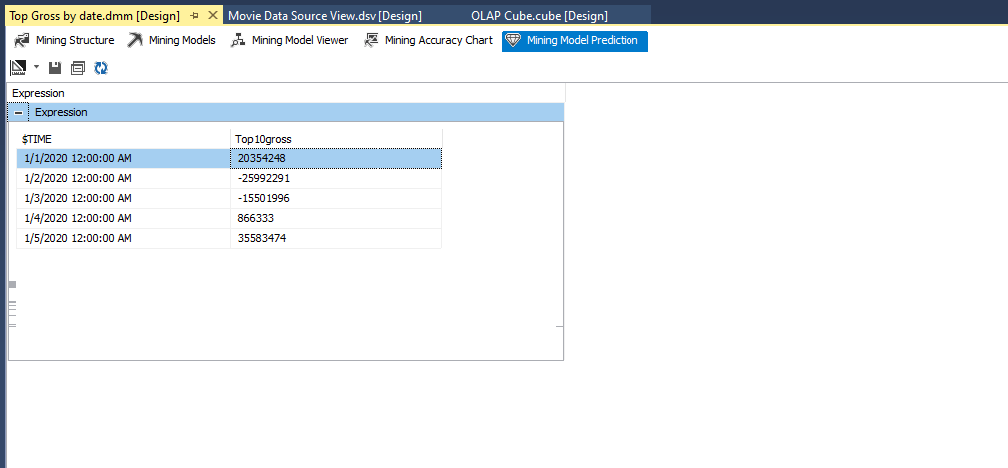

**REGRESSION MODEL**

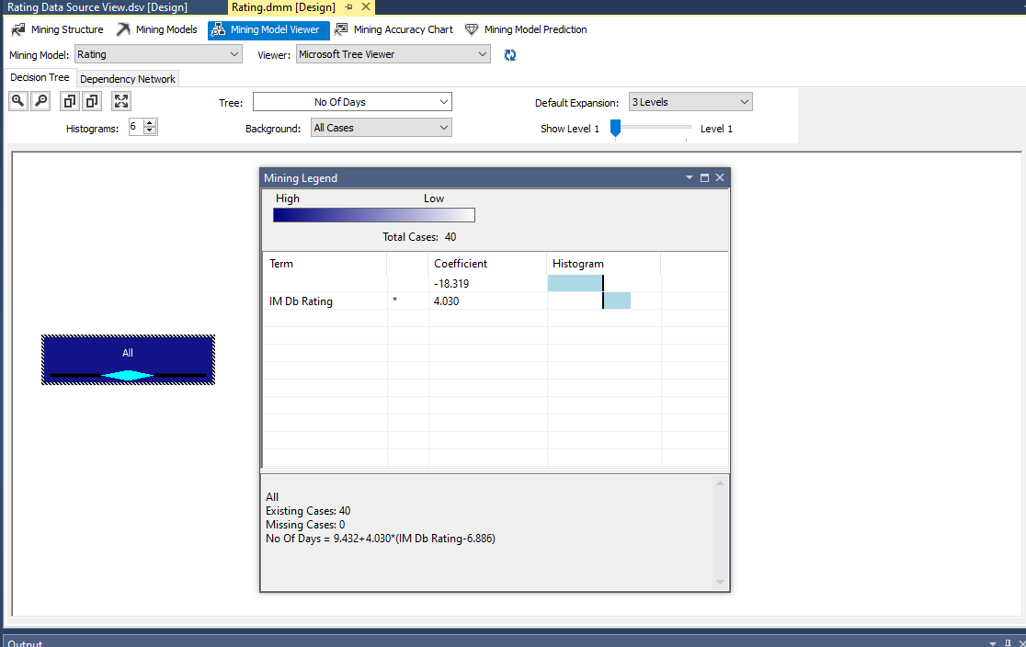

**SINGLETON QUERY FOR THE REGRESSION MODEL**

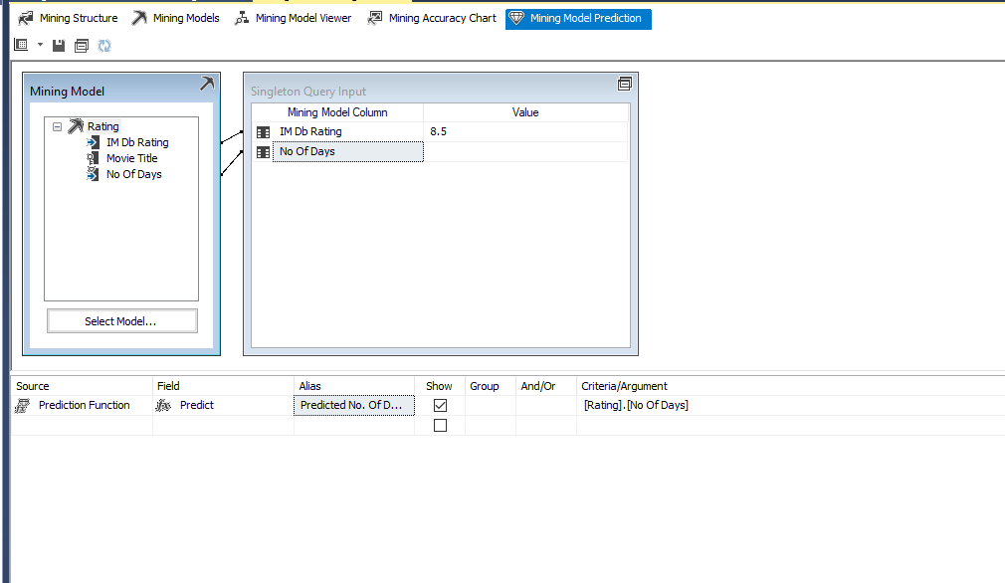

**PREDICTION OF SINGLETON QUERY**

